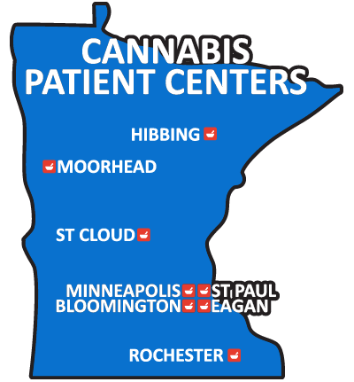

Location | Address | Phone | Hours
Bloomington | Bloomington  5232 W. 84th Street  Bloomington, MN 55431 | 800-514-3707 | Minnesota Medical Solutions Bloomington Hours
Eagan | 2795 Pilot Knob Road, Eagan, MN 55121 | 1-844-532-3546 | LeafLine Labs Eagan Hours
Hibbing | 302 East Howard Street  Hibbing, MN 55746 | 1-844-LEAFLINE (1-844-532-3546) | LeafLine Labs Hibbing Hours
Minneapolis | 207 South 9th Street, Minneapolis, MN 55402 | 1-800-514-3707 | Minnesota Medical Solutions Minneapolis Hours
Moorhead | 104 7th Street S. Moorhead, MN 56560 | 218-206-6600 | Minnesota Medical Solutions Moorhead Hours
Rochester | 3456 E. Circle Drive NE  Rochester, MN 55906 | 1-800-514-3707 | Minnesota Medical Solutions Rochester Hours
St. Cloud | 141 33rd Avenue South, St. Cloud MN 56301 | 1-844-532-3546 | LeafLine Labs St. Cloud Hours
St. Paul | 550 Vandalia Street  Saint Paul, MN 55114 | 1-844-LEAFLINE (1-844-532-3546) | LeafLine Labs St. Paul Hours

